Name-Ujjawal Mandhani
Batch-F6
Enroll No.-9918103237
ISL Lab – 2 B

Question 1:Write client and server programs to transfer the encrypted data between client and server. Use RSA Asymmetric key encryption for encrypting/decrypting the data.

#include <stdio.h>
#include <math.h>

int gcd(int a, int h)
{
int temp;
while (1)
{
temp = a % h;
if (temp == 0)
return h;
a = h;
h = temp;
}
}

int main()
{
double p = 3;
double q = 7;
double n = p * q;
double e = 2;
double phi = (p - 1) * (q - 1);
while (e < phi)
{
if (gcd(e, phi) == 1)
break;
else
e++;
}

int k = 2;
double d = (1 + (k * phi)) / e;

double msg = 20;

printf("Message data = %lf", msg);

double c = pow(msg, e);
c = fmod(c, n);
printf("\nEncrypted data = %lf", c);

double m = pow(c, d);
m = fmod(m, n);
printf("\nOriginal Message Sent = %lf", m);

return 0;
}

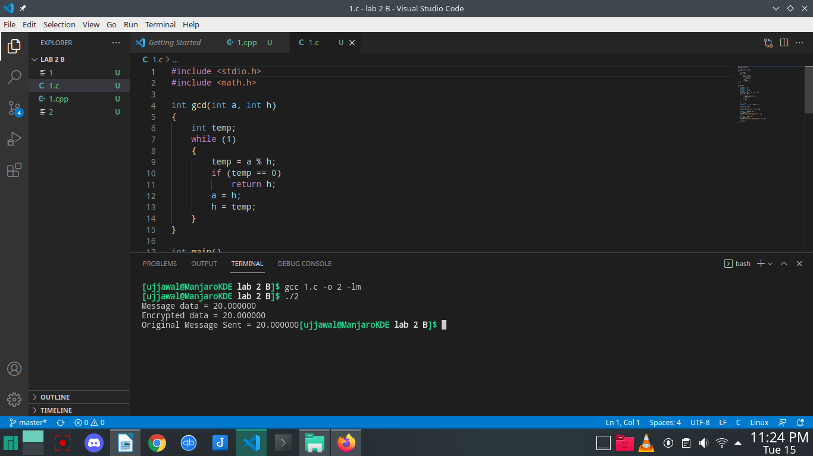

Question 2:Steganography is the hiding of a secret message within an ordinary message and the extraction of it at
its destination. Steganography takes cryptography a step farther by hiding an encrypted message so
that no one suspects it exists. Ideally, anyone scanning your data will fail to know it contains
encrypted data.
Example:
Plain text: Since Everyone Can Read, Encoding Text In Neutral Sentences Is Doubtfully Effective
Secret /hidden Message: “Secret inside”
Implement this technique and calculate the time delay.

#include <bits/stdc++.h>
using namespace std;
#define MAX_LEN 100

int main()
{
cout << "Enter the string: ";
char str[MAX_LEN];
cin.getline(str, MAX_LEN);
int n = 0;
for (int i = 0; str[i] != '\0'; i++)
{
n++;
}
cout << str[0];
for (int i = 1; i < n - 1; i++)
{
if (str[i] == ' ')
{
cout << str[i + 1];
}
}
cout << endl;
return 0;
}

